Jonathan Gunasingham

Website Design, 2021, Spring term

Professional Website – Jonathan Gunasingham

**I. Description of Testers**

The testers of the website were close acquaintances of the website creator. They all had professional backgrounds that ranged in variety, from social work to engineering to research, however they all had moderate website design experience which allowed them to make specific recommendations on specific elements of the website. This made for constructive feedback that was taken into strong consideration. It is unknown to what level the testers formally assess and evaluate individual professional websites, however their occupations involve them interacting and informally assessing the websites of several clients and stakeholders which created for valued and effective feedback.

**II. Description of Test Design**

Each tester was told to take no more than 10 minutes on browsing the website in order to focus on their initial impressions and the most pressing and prominent issues and aspects for the creator to adjust. Additionally since the website was on the more basic end of design, thorough analysis of the components and code was not required. Evaluations were provided on three areas: Design, Content, and Credibility/Professionalism. Each section was then broken down into various aspects that comprised the entire area and was rated on a scale of 1 to 5 using agree statements on a scale from Strongly Disagree to Strongly agree. The testers were not observed during the process, nor were they interacted with, except for one instance when one tester texted to inquire about the creator’s familiarity with a design element. All testers provided written feedback especially regarding the elements they rated either 3 or below.

**III. Analysis and Findings of Testing Results**

***Description of Assessment Measurement***

**The scores provided by each tester were put into a chart and summed to determine the total points earned out of the total points possible (five multiplied by the total amount of subcategories in a section). This score was then converted to a percentage for better clarity of the overall rating of the section. The percentages for each tester were also averaged in order to get an overall rating of each section and to better compare the assessments of each tester. The total points of each section were then summed together and converted to a percentage based on the total maximum amount of points in order to get an overall rating of the website by each user. This rating was also averaged between each used to get an overall assessment of the website and a comparison between each user’s overall assessment. The data is summarized in the Data Summary section below.**

***Data Summary***

**Percent Evaluations by Test Users\***

|  |  |  |  |  |  |
| --- | --- | --- | --- | --- | --- |
|  | **User 1** |  | **User 2** | **User 3** | ***Average*** |
| **Design (% score)** | 75.6 |  | 66.7 | 77.8 | 73.3 |
| **Content (% score)** | 85.7 |  | 77.1 | 82.9 | 81.9 |
| **Credibility (% score)** | 76.7 |  | 66.7 | 76.7 | 73.3 |
| ***Overall (% score)*** | ***79*** |  | ***70*** | ***79*** | **76.1** |

**\*Full Ratings found in Appendix B**

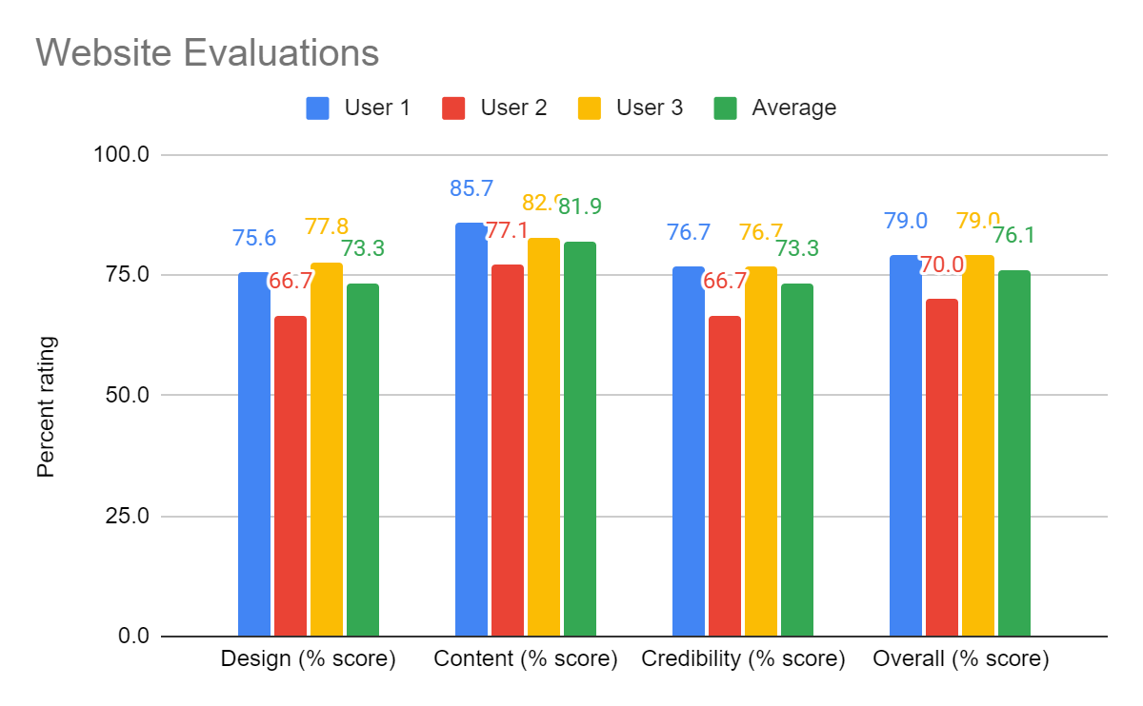

***Feedback Summary***

**Feedback was gathered for every section where potential improvements were mentioned and organized in a similar chart that housed the raw data. This allowed for easy comparison of the sections and issues that were most mentioned by the testers.**

**The most common was the broken links for the contact and experience pages which have not been built yet. Additionally comments about the sizing of the font were common, and more adjusting with the flexbox elements to make the auto adjusting intuitive will need to occur.**

**Full feedback can be found in the evaluation reports in Appendix A and the feedback summary in Appendix B.**

**Proposed Solutions to Correct Issues in Findings**

what can you do to fix any issues or address any suggestions made by your users,

The readability of the footer was a commonly mentioned issue among the testers. Part of the issue is the image being used, however the desire to keep that exists in order to emphasize some of the history and background of the creator. The font color was changed to black and the text was bolded which overall greatly improved readability.

Adjusting the dimensions included in the CSS for the responsive text will make the sizing of the text and images feel more appropriate based on screen size. This must be done through trial and error and an iterative process.

Testing of the video file works when opened from the computer folder, but not in the actual website. Different formats of embedding may be tested, such as uploading as a private link to YouTube, in order to get the video to appear online.

The background of the website may be adjusted in order to make website feel fuller. Background color may be changed to black and font color may be changed to white.

what suggestions do you think you would not change? - **1 full-page**

* **Color Scheme**

**Appendix A Copy of Testing Tool Used** (written responses and any notes taken - label them if you have multiple files per user tester!) - save these separately to show the responses you received.

**Appendix B: Data and Findings Charts**

**Table 1: Full Summary of Evaluation Scores**

|  |  |  |  |  |
| --- | --- | --- | --- | --- |
|  | ***User 1*** | ***User 2*** | ***User 3*** | ***Average*** |
| ***Total Points (out of 110)*** | ***87*** | ***77*** | ***87*** | ***83.7*** |
| ***Percentage*** | ***79*** | ***70*** | ***79*** | ***76.1*** |
| *Design* | | | |  |
| *Total Points (out of 45)* | *34* | *30* | *35* | ***33.0*** |
| *Percentage* | *75.6* | *66.7* | *77.8* | ***73.3*** |
| Category 1 | 5 | 4 | 5 | ***4.7*** |
| Category 2 | 2 | 4 | 2 | ***2.7*** |
| Category 3 | 5 | 5 | 5 | ***5.0*** |
| Category 4 | 5 | 5 | 5 | ***5.0*** |
| Category 5 | 3 | 2 | 4 | ***3.0*** |
| Category 6 | 1 | 2 | 3 | ***2.0*** |
| Category 7 | 3 | 3 | 5 | ***3.7*** |
| Category 8 | 5 | 2 | 4 | ***3.7*** |
| Category 9 | 5 | 3 | 2 | ***3.3*** |
| *Content* | | | |  |
| *Total Points (out of 35)* | *30* | *27* | *29* | ***28.7*** |
| *Percentage* | *85.7* | *77.1* | *82.9* | ***81.9*** |
| Category 1 | 5 | 5 | 5 | ***5.0*** |
| Category 2 | 5 | 3 | 5 | ***4.3*** |
| Category 3 | 1 | 2 | 2 | ***1.7*** |
| Category 4 | 4 | 5 | 5 | ***4.7*** |
| Category 5 | 5 | 3 | 2 | ***3.3*** |
| Category 6 | 5 | 5 | 5 | ***5.0*** |
| Category 7 | 5 | 4 | 5 | ***4.7*** |
| *Credibility* | | | |  |
| *Total Points (out of 30)* | 23 | 20 | 23 | ***22.0*** |
| *Percentage* | 76.7 | 66.7 | 76.7 | ***73.3*** |
| Category 1 | 5 | 5 | 5 | ***5.0*** |
| Category 2 | 3 | 1 | 2 | ***2.0*** |
| Category 3 | 5 | 5 | 5 | ***5.0*** |
| Category 4 | 5 | 3 | 5 | ***4.3*** |
| Category 5 | 3 | 4 | 5 | ***4.0*** |
| Category 6 | 2 | 2 | 1 | ***1.7*** |

**Table 2: Summary of Written Feedback**

|  |  |  |  |
| --- | --- | --- | --- |
|  | ***User 1*** | ***User 2*** | ***User 3*** |
| *Type of Computer* | Processor Intel(R) Core(TM) i5-6300U CPU @ 2.40GHz 2.50 GHz, System type 64-bit operating system, x64-based processor | Dell running with Windows 10 | Dell 7710 |
| *Browser* | Google Chrome Version 90.0.4430.212 (64-bit) | Chrome | Chrome Version 89.0.4389.128 |
| *Internet Connection* | guest connection to my wi-fi. | DSL | Cable |
| *Design* | | | |
| Category 1 | I mean this is pretty straight forward. You have a nav bar at the type divided into what I would expect to find on a website about your career. | Logical and I like the layout but several of the links do not currently work, mostly on the professional experiences page and contact link |  |
| Category 2 | I feel like the background colors and too bright and there are some floating quotes which I’m not used to in a website. I’m also wondering if you had to put that into the website as part of the assignment. Haha. I also think the font size is too big. I JUST SAW THE FOOTER!! Jon, that’s horrible. I would do something a little different with a solid blue line to match the title bar colors at the top with white text for your contact information. Then below that I’d make a site map so people can get back to where they want to go really quickly. You could even move your contact information to buttons. Check out my company’s website at their footer. You don’t need a picture but something like that: https://helpingpeople.org/. | I would center your Welcome banner text to match your navigation buttons. | Font sizes are somewhat inconsistent. |
| Category 3 | Nav bar in logical place. Lots of links to other pages of your website. Nav bar never goes away. I like it. |  | I would like to see the maximum width for the pages main text limited so the text does not fill the whole screen when the window is maximized. Same for the banners. |
| Category 4 | Yes. It is. Nav bar never goes away. |  | Some of the images expand and shrink with the window. This can be nice, but restrict your image sizes to so can’t get too big. I don’t like the colors, but what do I know about colors? Horizontal scrolling banner? Delete it. |
| Category 5 | Personally I wouldn’t have so many but that’s ok. | Links to social media don’t work currently. And there is an error message for your video on your “About Me” page | Flow of the website is nice. |
| Category 6 | I’m giving this a one for two reasons: your video resume wasn’t linked appropriately so it was a 404 error. And because when I clicked the link for your paper resume it didn’t open in a new link. That’s like a pet-peeve of mine for links taking you to an external page. <a href=”resume.pdf” target=”_blank”>here</a>. |  | The video resume did not load. Everything else is fine. |
| Category 7 | I’m too lazy to check all the images. The couple I looked at didn’t have height attributes. But you don’t really need to do that from my understanding. | yes, but it really messes with your text boxes the way it’s setup |  |
| Category 8 |  | I don’t love the blue background with purple text once it is highlighted. Hard to read. | Weird font sizes |
| Category 9 |  |  | The links for your experiences do not work |
| *Content* | | | |
| Category 1 |  |  |  |
| Category 2 |  |  |  |
| Category 3 | Some of your links are broken. All references to the Contact page or the three subpages under Professional Experience are broken. I took a look at the code and it’s right so I’m not sure what happened. | Many of your links do not currently work | The 3 experience links and contact link do not work |
| Category 4 | This is true. But if this website is tailored toward parents/students/future jobs I would put your resume on the first page. |  |  |
| Category 5 |  |  |  |
| Category 6 |  |  |  |
| Category 7 | This is very clearly a website about Jon as a teacher for students/parents/future jobs. |  |  |
| *Credibility* | | | |
| Category 1 |  |  |  |
| Category 2 |  | It’s in your professional resume..too many layers deep to be convenient like all other info. Not currently working on contact link. I think it’s listed in your bottom of the page banner but I can’t read it with the current text. | Your email is at the bottom but it is very difficult to read. Contact link does not work |
| Category 3 |  |  |  |
| Category 4 |  |  |  |
| Category 5 | Some mistakes here and there. |  |  |
| Category 6 | No dates that I can see. | Again, I think this is in your lower page banner but I can’t read it. | I don’t see any dates. |